# JetLagged-Prediction of Airline Flight Delay

Submitted in partial fulfillment of the requirements of the degree

## BACHELOR OF ENGINEERING IN COMPUTER ENGINEERING

By

**Ved Waje D12A/64**

**Abhirat More D12A/44**

**Pranita Bannore D12A/8**

**Harshita Lohana D12A/38**

Name of the Mentor

**Prof. Mrs. Vidya Zope**



## Vivekanand Education Society’s Institute of Technology,

**An Autonomous Institute affiliated to University of Mumbai**

## HAMC, Collector’s Colony, Chembur, Mumbai-400074

**University of Mumbai (AY 2024-25)**

# CERTIFICATE

This is to certify that the Mini Project entitled **“JetLagged-Prediction of Airline Flight Delay”** is a bonafide work of **Ved Waje (64), Abhirat More (44), Pranita Bannore (8), Harshita Lohana (38)** submitted to the University of Mumbai in partial fulfillment of the requirement for the award of the degree of **“Bachelor of Engineering”** in **“Computer Engineering”.**

#### (Prof. Mrs. Vidya Zope)

Mentor

#### ( Dr.(Mrs.) Nupur Giri ) (Prof. J.M. Nair)

Head of Department Principal

# Mini Project Approval

### This Mini Project entitled “**JetLagged-Prediction of AIrline Flight Delay”**

by **Ved Waje (64), Abhirat More (44), Pranita Bannore (8), Harshita Lohana (38)** is approved for the degree of **Bachelor of Engineering** in **Computer Engineering.**

**Examiners**

**1………………………………………**

(Internal Examiner Name & Sign)

#### 2…………………………………………

(External Examiner name & Sign)

Date: Place

# Contents

#### Abstract i

#### Introduction 1

* 1. Introduction
  2. Motivation
  3. Problem Statement & Objectives
  4. Organization of the Report

1. **Literature Survey 6**
   1. Survey of Existing System
   2. Limitation Existing system or Research gap
   3. Mini Project Contribution

#### Proposed System 9

* 1. Introduction
  2. Architectural Framework / Conceptual Design
  3. Algorithm and Process Design
  4. Methodology Applied
  5. Hardware & Software Specifications
  6. Experiment and Results for Validation and Verification
  7. Result Analysis and Discussion
  8. Conclusion and Future work.

#### References 22

**ABSTRACT**

In the present scenario of airline flights, there have been numerous instances of flight delays and cancellations. Flight delays and cancellations are common issues in the airline industry, affecting both passengers and airlines. These disruptions can result from a variety of factors, including adverse weather conditions, technical malfunctions, air traffic congestion, and crew availability problems. To tackle these challenges, this project aims to develop an advanced deep learning based web application designed to identify and analyze the primary causes of flight delays and cancellations. This application will integrate and analyze data from multiple sources, such as weather reports, flight schedules, and historical delay records. Notably, the interconnected nature of these factors poses a significant challenge, as delays in one segment can lead to cascading effects throughout the entire network. By employing sophisticated deep learning models, it will detect patterns and correlations that contribute to these disruptions. The integration of such diverse datasets allows for a comprehensive understanding of the dynamics involved in flight delays. The primary objective is to offer a comprehensive tool that enables airlines and passengers to understand and predict potential delays more effectively. Additionally, the application aims to provide real-time alerts and recommendations to the passengers. This proactive approach will facilitate better decision-making, thereby enhancing overall operational efficiency within the airline industry. Furthermore, by leveraging advanced data analytics and deep learning techniques, the system seeks to contribute to a more resilient airline industry, potentially paving the way for future innovations in predictive analytics.

The proposed system will be an invaluable resource for analyzing and addressing the factors that lead to flight delays. By improving the ability to predict and manage these disruptions, the system aims to enhance the travel experience for passengers and reduce operational costs for airlines. Ultimately, this project represents a significant advancement in utilizing deep learning technology to improve reliability and efficiency in air travel, benefiting the entire airline ecosystem through innovative and data-driven solutions. This initiative aligns with the broader goals of digital transformation and smart transportation systems, highlighting the role of technology in shaping the future of global connectivity.

1**.Introduction**

1.1 Introduction

The airline industry plays a crucial role in global transportation, facilitating the movement of millions of passengers and goods daily. However, flight delays and cancellations are persistent issues that disrupt travel schedules, cause financial losses, and lead to passenger dissatisfaction. Understanding the underlying causes of these disruptions is essential for improving airline operations and enhancing the passenger experience. Flight delays and cancellations can stem from various factors, including adverse weather conditions, technical malfunctions, late arrivals of connecting flights, and crew-related issues. These factors can be interrelated, making it challenging to predict and manage delays. Traditional methods of delay prediction often fall short due to the complexity and volume of data involved. In this project, we propose the development of a deep learning-based web application to identify and analyze the primary causes of flight delays and cancellations. By leveraging advanced deep learning techniques, the application aims to process and analyze large datasets, including weather data, flight schedules, and historical delay records. The goal is to uncover patterns and correlations that contribute to flight disruptions, providing valuable insights for both airlines and passengers. The application will not only predict potential delays but also offer recommendations for mitigating their impact. By providing real-time data and predictive insights, the system can assist airlines in optimizing their operations and improving decision-making processes. Passengers, on the other hand, can benefit from timely information about potential delays, allowing them to plan their journeys more effectively.

1.2 Motivation

The airline industry plays a pivotal role in the global transportation network, enabling the efficient movement of passengers and goods across the world. Every day, millions of people rely on airlines to connect cities, countries, and continents, making air travel an indispensable part of modern life. However, one of the most persistent and disruptive challenges faced by both airlines and passengers is flight delays and cancellations. These disruptions not only inconvenience travelers but also lead to substantial economic losses for airlines and other related industries. As air traffic continues to increase, there is a growing need to find more effective ways to predict and manage these delays to enhance operational efficiency and improve the overall passenger experience. the potential impact this project could have on both airlines and passengers. For airlines, more accurate delay predictions can lead to better resource allocation, improved decision-making, and reduced operational costs. Airlines can proactively adjust their schedules, manage crew availability, and optimize airport operations based on real-time predictions, resulting in fewer delays and improved overall efficiency. For passengers, access to real-time delay information allows for better travel planning, reducing stress and uncertainty associated with unexpected disruptions. Passengers can make informed decisions about rebooking, adjusting connections, or altering travel plans, leading to a smoother and more pleasant travel experience. The motivation behind this project is driven by the desire to solve a pressing problem in the airline industry using deep learning techniques. By providing airlines and passengers with accurate, real-time insights into potential disruptions, we hope to make air travel more reliable, efficient, and enjoyable for everyone involved. The potential for widespread application and long-term benefits makes this project both timely and impactful, with the ability to significantly improve the way we approach and manage flight delays in the future.

1.3 Problem Statement & Objectives

The airline industry is frequently challenged by flight delays and cancellations, which can result in significant economic losses and inconvenience for both airlines and passengers. These disruptions can be caused by a multitude of factors, including but not limited to:

1. **Adverse Weather Conditions**: Weather events such as thunderstorms, snowstorms, and fog can lead to delays and cancellations, disrupting flight schedules and causing logistical challenges.
2. **Technical Malfunctions**: Mechanical issues or system failures in aircraft can lead to delays while repairs or maintenance are conducted to ensure passenger safety.
3. **Air Traffic Congestion**: High traffic volumes at airports can cause delays in takeoffs and landings, leading to cascading delays across the network.
4. **Crew-Related Issues**: Crew availability, regulatory rest requirements, and logistical challenges in crew scheduling can also contribute to delays.
5. **Operational Inefficiencies**: Inefficient processes in ground handling, baggage handling, and other operational aspects can result in delays.

Despite the availability of data from various sources, including weather reports, flight schedules, and historical flight data, the airline industry lacks an integrated, data-driven solution to predict and understand the root causes of these delays and cancellations effectively. Traditional predictive models often fail to capture the complex interplay of factors that lead to disruptions.

To address this gap, the project aims to develop a deep learning-based web application that can analyze large datasets and identify the primary causes of flight delays and cancellations. By utilizing advanced deep learning techniques, the application will provide real-time predictions and insights, helping airlines optimize their operations and improve decision-making. Additionally, the application will inform passengers about potential delays, enhancing their travel planning and experience.

1.4 Organization of the Report

The **Literature Survey** section provides a comprehensive review of existing systems and research related to jet lag, flight delay prediction, and other relevant topics. This part of the report discusses the current technologies, tools, and methodologies used in the field. It highlights their capabilities and limitations, establishing a foundation for understanding the current state of the art. The **Survey of Existing Systems** dives deeper into the mechanisms behind these systems, showcasing their strengths and areas where they fall short. Following this, the **Limitations of Existing Systems / Research Gap** outlines the critical issues or inefficiencies that remain unaddressed, such as limited predictive accuracy, outdated data sources, or lack of user-centered design. This gap paves the way for our contribution. The **Mini Project Contribution** section presents the unique aspects of our project, *Jetlagged*, by demonstrating how it fills these gaps. It could involve innovations in model accuracy, better data integration (such as live flight tracking), or improved user experience through the mobile app interface.

In the **Proposed System** section, the report begins with an **Introduction** to our system, explaining its purpose and significance. This is followed by the **Architectural Framework / Conceptual Design**, where the overall structure and key components of *Jetlagged* are detailed, explaining how data flows from input (user flight details, API data) to output (predicted delays and suggestions). The **Algorithm and Process Design** delves into the specific algorithms and processes used for predictions, such as any machine learning models, data preprocessing steps, or decision rules based on weather and flight conditions. Next, the **Methodology Applied** section elaborates on the overall approach, including the steps taken for system development, testing, and deployment. The **Hardware and Software Specifications** outlines the technical requirements, such as tools, libraries, and platforms used in both development and execution phases.

The **Experiment and Results for Validation and Verification** section presents the results from testing the system, showcasing how well the proposed solution works in real-world conditions. It includes experiments to verify the accuracy of the predictions and performance metrics compared to existing solutions. In **Result Analysis and Discussion**, the findings from the experiments are analyzed in detail. This includes a discussion of the strengths, any unexpected results, and how they compare to the original goals of the project. Finally, the **Conclusion and Future Work** section wraps up the report by summarizing the key outcomes and suggesting possible future improvements, such as expanding the system to incorporate additional data sources or further optimizing the prediction algorithms.

.

2.**Literature Survey**

2.1 Survey of Existing System

|  |  |
| --- | --- |
| **Paper Title** | **Paper Description** |
| A Deep Learning Approach for Flight Delay Prediction Through Time-Evolving Graphs [1] | The paper presents a GCN-based approach for predicting flight delays in multi-airport networks by modeling time-varying spatial interactions. |
| Flight Delay Prediction Using Machine Learning [2] | This paper predicts flight delays due to bad weather at JFK airport, comparing various machine learning algorithms, with XGBoost achieving the best performance. |
| Iterative machine and deep learning approach for aviation delay prediction [3] | It presents an iterative approach using machine learning and deep learning techniques to predict aviation delays. The study aims to improve the accuracy of delay predictions by leveraging advanced algorithms and iterative refinement processes. |
| A Flight Delay Prediction Model with Dynamic Temporal Convolutional Network [4] | It presents a model that leverages dynamic temporal convolutional networks to predict flight delays more accurately by capturing complex temporal dependencies in flight data. The proposed approach enhances prediction performance compared to traditional methods, offering potential improvements in operational efficiency for airlines. |
| Flight Delay Prediction Based on Multi-Layer Perceptron [5] | It presents a model utilizing a multi-layer perceptron to predict flight delays, aiming to improve prediction accuracy by leveraging various flight-related data. The study demonstrates the effectiveness of the neural network approach in handling the complexity and variability of flight delay factors. |

|  |  |
| --- | --- |
| Research on flight arrival delay prediction based on support vector machine [6] | This paper proposes a support vector machine model for predicting flight arrival delays using flight plan data, highlighting the impact of flight planning and sample size on prediction accuracy. |
| A Review of Flight Delay Prediction Methods [7] | This paper reviews flight delay prediction methods, including statistical, simulation, queuing theory, and machine learning approaches, and suggests future research directions. |
| Machine Learning Model - based Prediction of Flight Delay [8] | This paper predicts flight arrival delays using US domestic flight and weather data, applying XGBoost for binary classification and linear regression for delay time prediction |

2.2 Limitation Existing system or Research gap

Despite significant advancements in the airline industry, existing systems for predicting flight delays and cancellations still face several limitations, revealing key research gaps that need addressing. Traditional methods primarily rely on statistical models or simple machine learning algorithms, which struggle to capture the complexity and interdependence of the factors contributing to flight disruptions. These approaches are heavily reliant on historical data and often fail to incorporate real-time information effectively, reducing their accuracy in fast-changing environments.

Flight delays are influenced by a wide range of variables, including weather conditions, air traffic, crew availability, aircraft maintenance, and connecting flights. The intricate interconnections between these factors make it difficult for conventional models to fully capture their combined effects. Additionally, many of these systems do not effectively use real-time data sources, such as live weather updates or air traffic control information, leading to delayed or inaccurate predictions. Moreover, existing models often overlook hidden patterns and correlations within the data that could enhance prediction accuracy. Although deep learning algorithms are better suited to handling complex, non-linear relationships, their use in current flight delay systems remains limited. Furthermore, many existing systems focus on a narrow set of variables, such as weather or flight schedules, without considering the broader range of factors that can impact delays. For instance, disruptions at one airport can trigger a chain reaction, affecting flights across multiple locations—a cascading effect that many models fail to account for. The lack of integration between different data sources, such as weather data, flight logs, and crew schedules, further reduces the overall effectiveness of delay predictions. The flight delay prediction systems still face critical limitations, including insufficient use of real-time data, limited adoption of advanced deep learning techniques, and inadequate integration of multiple data sources. These gaps present opportunities for improvement, and this project seeks to address them by leveraging modern technologies to deliver more accurate and actionable insights, ultimately enhancing decision-making and the passenger experience in the airline industry.

2.3 Mini Project Contribution

This mini project significantly contributes to the prediction of flight delays and cancellations through an innovative, data-driven approach. By employing advanced machine learning techniques, specifically deep learning, it addresses the shortcomings of existing systems and aims to deliver more accurate predictions. A primary aspect of this contribution is the incorporation of real-time data, such as live weather updates, flight status, and air traffic information. This dynamic data integration enables timely and reliable predictions, offering substantial improvements over traditional methods.

The project utilizes sophisticated deep learning algorithms capable of capturing complex, non-linear relationships among various factors influencing delays. By analyzing large and diverse datasets, the model identifies hidden patterns and correlations that conventional approaches often overlook, resulting in enhanced predictive accuracy. Additionally, a comprehensive dataset is leveraged, encompassing elements like weather conditions, flight schedules, crew availability, air traffic control data and aircraft maintenance records. This thorough approach ensures that the model considers the full spectrum of variables affecting airline operations. The project includes a user-friendly android and web application that presents real-time predictions along with actionable insights. This platform allows airlines and passengers to access timely information and recommendations for mitigating delays, thus improving decision-making and travel planning. Passengers benefit from a smoother travel experience, as they can adjust their plans based on accurate predictions, while airlines can better manage operations to minimize financial impacts and improve overall efficiency. In addition to enhancing the prediction capabilities, the project also aims to contribute to the field of airline operations management. By providing insights into the factors contributing to delays, airlines can implement more effective strategies to address potential disruptions. This could involve adjusting schedules, reallocating resources, or improving communication with passengers regarding potential issues. Ultimately, the project aims for passenger's smooth travel experience, while airlines can better manage operations and minimize financial impacts.

#### 

#### 3. Proposed System

3.1 Introduction

In the proposed system, we aim to provide a comprehensive flight delay prediction solution by combining machine learning, real-time data retrieval, and mobile application development. The backbone of the system is a LightGBM Regressor model, trained on historical flight data to predict arrival delays based on multiple influencing factors such as departure location, destination, weather conditions, airport rating, airline rating, and the distance between airports. We employed Optuna, a powerful hyperparameter optimization framework based on Bayesian optimization, to fine-tune the model and enhance its predictive accuracy. By optimizing the model’s hyperparameters, we ensure that it can adapt to complex flight scenarios and deliver reliable delay predictions.

The system is designed to be both flexible and scalable by utilizing a Flask API, which serves as the bridge between the machine learning model and the user-facing application. Users can send key flight parameters to the API, including the origin and destination airports, current weather, and ratings of airports and airlines. The model processes this input and predicts the likely arrival delay. Additionally, when live flight data is available, the system factors in the actual departure delay, which is a significant predictor of arrival delays. The weather data is dynamically fetched for the precise latitude and longitude of the flight's location, ensuring that the predictions are grounded in real-time environmental conditions. If live data isn’t available, the model assumes a departure delay of zero and uses the weather conditions of the source airport’s city to make predictions, thereby providing a fallback mechanism to ensure usability even in the absence of real-time data.

The JetLagged mobile app, built using Flutter, is the user interface of the system. Through the app, users can enter a flight number, and the app fetches real-time flight details such as departure, destination, and current flight status using the AviationStack API. Additionally, the app integrates with a weather API to retrieve real-time weather data for the flight’s route. These details are then passed to the Flask API, which processes the input and predicts the flight’s arrival delay. This real-time prediction is displayed in the app, providing users with valuable information to plan their travel better. In the case where live flight data is available, the model accounts for the departure delay, making the prediction more accurate. If not, historical data and weather conditions from the source airport’s city are used as proxies, ensuring that the system remains functional in various scenarios. A unique feature of JetLagged is the ability to visualize the flight's live location on a map. Upon entering a flight number, the app plots the flight's real-time position on the map using latitude and longitude data from the API. Users can click on the flight's marker to view detailed flight information, such as departure time, destination, and current status, all in an intuitive, visual format. This feature allows travelers not only to monitor delays but also to see exactly where their flight is in real-time, providing a holistic, engaging, and informative experience to users.

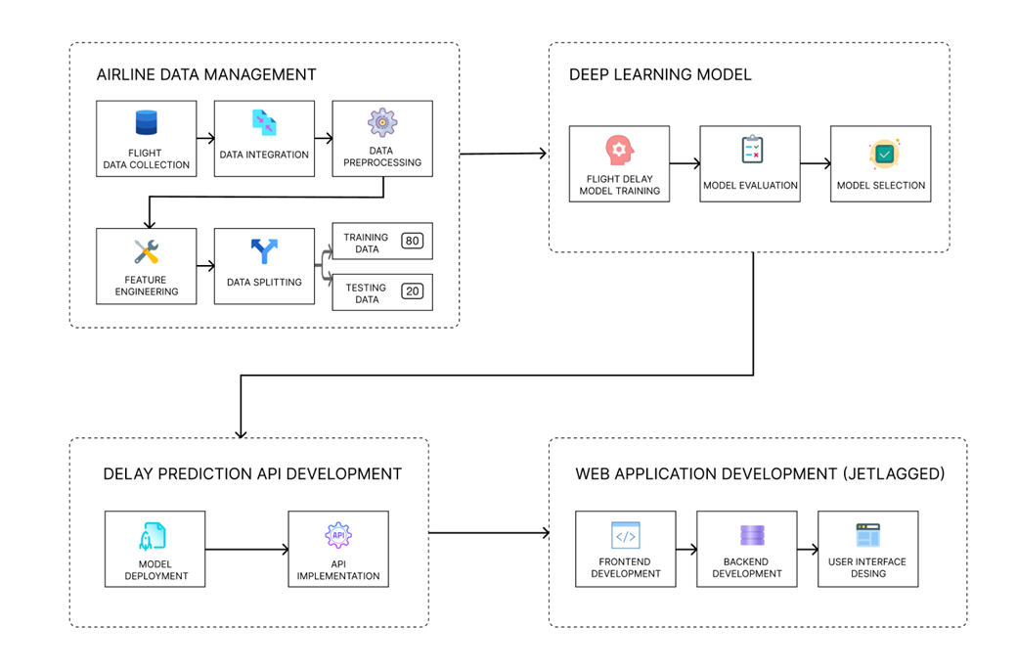

Fig.3.1. Block diagram of the delay prediction system

3.2. Architectural Framework

Airline Flight Delay Prediction System follows a Microservices-based Architecture. **Microservices Architecture** breaks down a large system into smaller, independent services, each responsible for a specific function. These services communicate with each other through APIs or message brokers.



*Fig. 3.2. Microservice Architecture*

**1. Data Layer (Data Collection)**

The system collected historical and real-time flight records, including arrival times, delays, and schedules from sources such as airline databases and public APIs. For flight data, the AviationStack API was utilized. Additionally, real-time and historical weather data were gathered via external APIs, specifically using WeatherAPI.com.

**2. Data Processing and Preprocessing Layer**

The data preprocessing service performed ETL (Extract, Transform, Load) operations by fetching data from multiple sources. It cleaned the data, handled missing values, encoded categorical variables (e.g., flight statuses), and performed feature engineering, such as creating new columns like flight time. The processed data was stored and made ready for model training.

**3. Model Training Layer**

The system employed the LGBM Regressor (LightGBM) as the deep learning model to predict flight delays by analyzing time-series data. The model was trained on the processed data, and model versioning was implemented to allow for easy updates and tracking of the trained models.

**4. Prediction API Layer**

A RESTful API was developed for real-time delay prediction. This API received flight details, such as flight number, departure time, and weather conditions, and returned predicted delays. It interacted with the trained LGBM Regressor model to generate predictions based on real-time data.

**5. Web Application Layer**

The web application provided a user interface where users could input flight details and view predicted delays. The frontend is designed to be user-friendly and accessible across devices, allowing for real-time interaction with the prediction API to fetch delay predictions dynamically.

**6. Model Deployment Layer**

The trained LGBM Regressor model was deployed in a production environment for real-time use. The deployment involved packaging the model into containers to facilitate easy management and scaling. Optuna was used for hyperparameter tuning during the model training phase, optimizing the model’s performance by efficiently exploring various hyperparameter combinations.

**7. User Interface Design Layer**

The user interface was designed to enhance user experience, providing a responsive and intuitive layout. It allowed users to interact with the system seamlessly, presenting historical delay patterns and model predictions in a clear and visually appealing manner.

3.3 Algorithm and Process Design

**Algorithm:**

The JetLagged application employs the LightGBM (Light Gradient Boosting Machine) algorithm for flight delay prediction, leveraging its efficiency and scalability. LightGBM is particularly well-suited for handling large datasets with high-dimensional features, making it ideal for the extensive flight data utilized in this project. Its capability to manage missing data reduces the need for exhaustive preprocessing, while its support for categorical features, such as airport codes and airlines, allows for seamless integration of diverse inputs. The model takes several key features into account, including the distance between airports, airline and airport ratings, as well as weather conditions at either the flight's source or current location. Notably, if real-time departure delay information is available, it is included in the model; otherwise, the departure delay is assumed to be zero.

To enhance the model's performance, hyperparameters were optimized using Optuna, a framework based on Bayesian optimization. This process focused on critical parameters such as the learning rate, max depth of decision trees, and the number of estimators to control the boosting rounds. During the training phase, the model minimizes the Mean Squared Error (MSE) between predicted and actual arrival delays, utilizing a k-fold cross-validation process to ensure robustness and generalization. Furthermore, LightGBM's inherent feature importance ranking allows for the identification of significant factors contributing to delay predictions, ensuring that elements like departure delay, weather conditions, and airport ratings are prioritized in the decision-making process. Ultimately, the model outputs the predicted arrival delay in minutes, providing valuable insights to users through the JetLagged application.

**Process Design:**

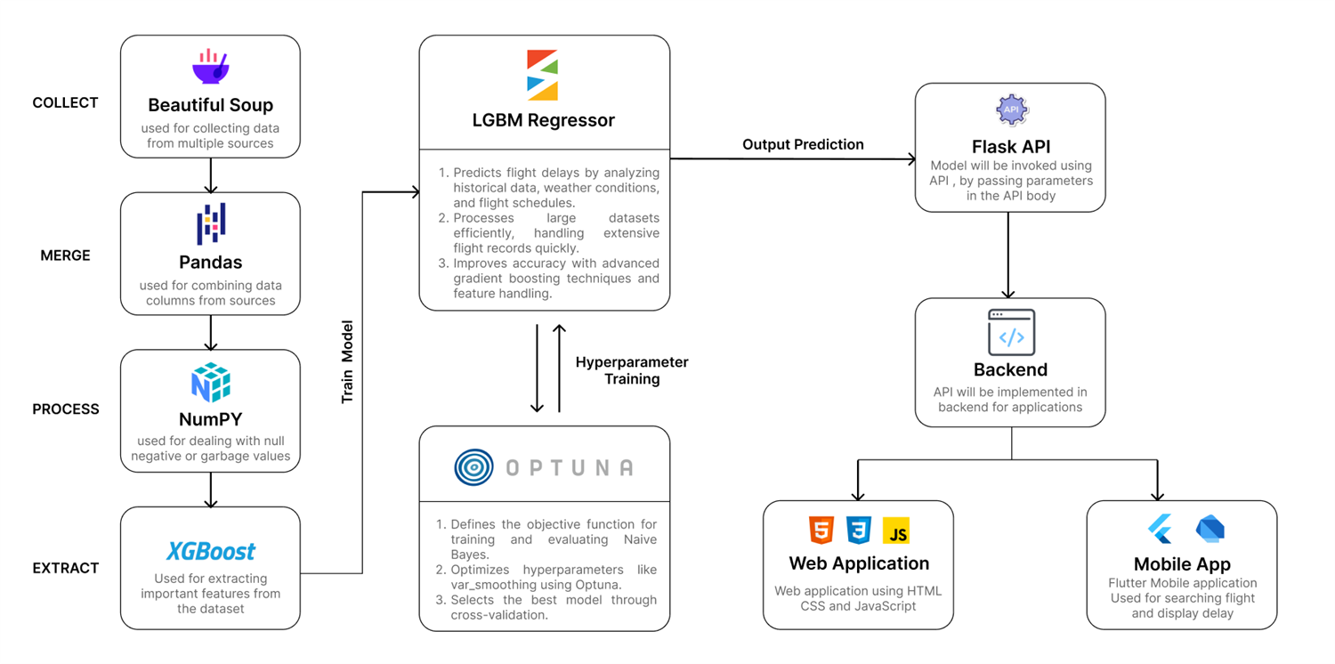

Fig. 3.3. Modular diagram of the delay prediction system

The process design for the JetLagged application encompasses a comprehensive workflow that begins with data collection and extends through model development, API integration, and application deployment. Initially, historical flight data is gathered using web scraping techniques with Beautiful Soup, targeting various aviation-related websites to extract essential information such as flight schedules, delays, and cancellation rates. This raw data undergoes thorough cleaning and preprocessing, where it is standardized and formatted for analysis. Missing values are addressed through interpolation or imputation, and outliers are identified and managed to maintain data integrity. Subsequently, the cleaned datasets are merged, combining historical flight information with real-time weather data obtained through an API. This integrated dataset serves as the foundation for our predictive modeling.

Once the dataset is ready, we leverage the LightGBM algorithm for model training. LightGBM, known for its efficiency with large datasets and its ability to handle categorical features directly, is chosen for its superior performance in regression tasks. The dataset is divided into training and validation sets to facilitate model evaluation. To further enhance model performance, we employ Optuna, a hyperparameter optimization framework that uses Bayesian optimization techniques. Optuna allows for the automatic tuning of various hyperparameters, such as the number of leaves, learning rate, and boosting type, resulting in a model that is finely optimized for predicting flight delays. The trained model is then encapsulated within a Flask API, designed to handle incoming requests. This API receives user-provided parameters, including flight number, departure and arrival airports, and current weather conditions, and returns the predicted arrival delay based on the input data.

The final stage of the process design involves creating the JetLagged application, a user-friendly interface built with Flutter that allows users to easily access flight delay predictions. Users can enter flight information, and the app utilizes the AviationStack API to fetch real-time flight details, including current status and departure delays. In scenarios where live flight data is available, the app considers the actual departure delay; otherwise, it assumes a departure delay of zero and defaults to the weather conditions of the departure airport city. The application also incorporates a visualization feature that displays the flight’s location on a map, enhancing user engagement by allowing users to interactively track flights. This comprehensive process design not only ensures accurate predictions but also provides a seamless user experience, making JetLagged a valuable tool for travelers.

3.4 Methodology Applied

The methodology applied in the JetLagged application is designed to provide users with accurate predictions of flight delays based on real-time data and a well-trained predictive model. The process begins when the user inputs the IATA code of their desired flight into the app. This code serves as a unique identifier for the flight and triggers an HTTP request to the AviationStack API to retrieve essential details, including the departure delay, source and destination airports, and the airline name. To enhance the predictive capability of the application, a mapping system is implemented that associates airline and airport ratings based on the retrieved airline name. Additionally, the distance between the source and destination airports is calculated, which is crucial for the delay prediction model.

Next, the application integrates weather data to further refine the delay prediction. If the live coordinates for the flight are available, the weather conditions at those coordinates are fetched using a weather API. In scenarios where live coordinates are not accessible, the app defaults to using the weather information from the source airport city. This ensures that the model is always utilizing the most relevant weather data to account for potential impacts on flight delays. With all this information gathered, including the departure delay, airport ratings, distance, and current weather conditions, the data is preprocessed into a format suitable for the trained predictive model.

The preprocessed data is then passed to a Flask API that hosts the LightGBM model, which has been hypertuned using Optuna for optimal performance. This model analyzes the input data and predicts the expected arrival delay. The predicted delay is then displayed to the user in the JetLagged app, providing them with timely and actionable information regarding their flight. This methodology not only ensures the accuracy of the predictions but also enhances the overall user experience by integrating various data sources into a seamless workflow.

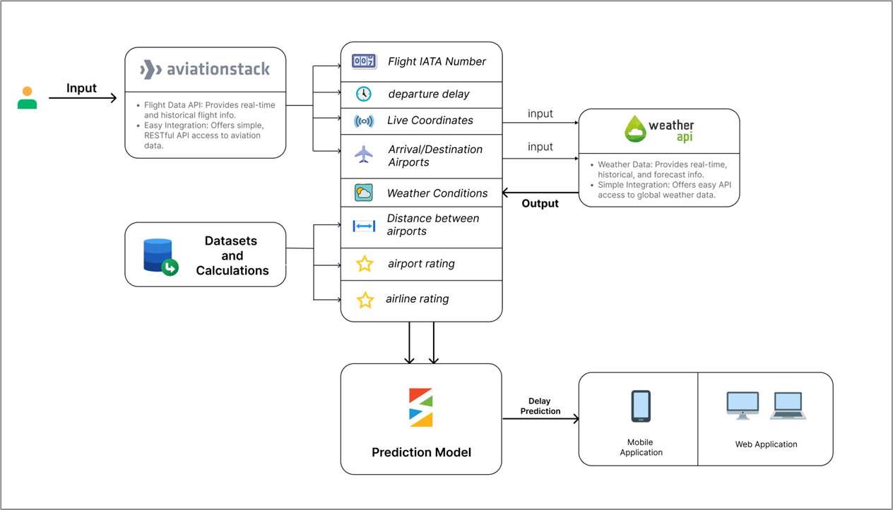

Fig. 3.4. data sources and flow of data in the system

3.5 Hardware & Software Specifications

**Hardware Requirements:** Multi-core CPUs, High-performance GPUs, PC and Mobile Phone

**Software Requirements: Windows** or macOS for development machines, Database Management Systems (PostgreSQL, MySQL), Programming Languages (Python, JavaScript, SQL, Dart), Data Analysis Tools (Pandas, NumPy, SciPy, Sklearn)

**Tools Requirements:** Git, Repositories (GitHub, GitLab), Integrated Development Environments (PyCharm, Postman, VS Code, Docker)

3.6 Experiment and Results for Validation and Verification

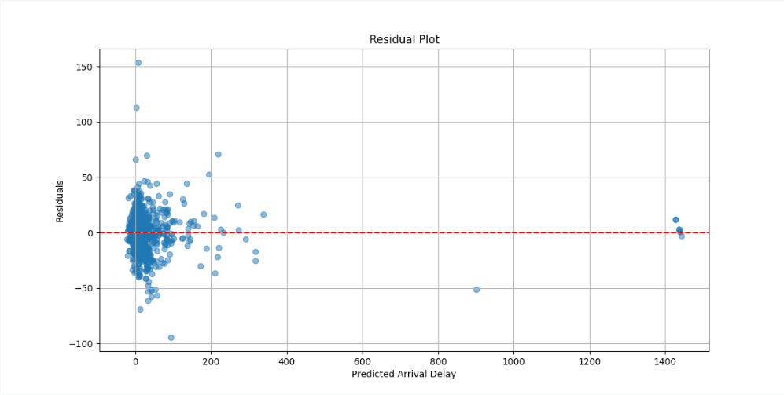

*Fig. 3.5 Scatter plot showing relation between predicted and actual delay*

The scatter plot illustrates the relationship between actual and predicted flight arrival delays. Each point represents a flight, with the x-axis showing actual delays and the y-axis showing predicted delays. Ideally, points should cluster near the diagonal red dashed line, indicating accurate predictions. If the points are widely dispersed or reveal a pattern, it suggests the model may struggle to generalize, leading to inaccurate predictions for certain delay ranges.

**JetLagged Application Screenshots:**

|  |  |
| --- | --- |
|  |  |
| (A) (B)  Fig 3.6 Interface to enter Flight Number | |

|  |  |
| --- | --- |
|  |  |
| (A) (B)  Fig. 3.7 Invalid Flight Number and Plotting of flight on map | |

If the user enters an incorrect Flight IATA number, the message **"Invalid Flight Number"** will be displayed prominently. Once the user enters a valid Flight IATA number, the flight will be plotted on the map. If there are no live details available for the entered flight, a snackbar notification will appear, stating **"No Live Data Available."**

|  |  |
| --- | --- |
|  |  |
| (A) (B)  Fig 3.8. Fetching the details of the live flight | |

After the user clicks on the flight icon, detailed information about the flight is displayed, fetched from AviationStack. This includes crucial details such as the flight number, departure and arrival times, current flight status, airline, aircraft type, and the airport codes for both departure and arrival. Additionally, other relevant flight details will be shown above, providing a comprehensive overview of the flight's status and progress.

3.7 Result Analysis and Discussion

### **Result Analysis**

The application, **Jetlagged**, successfully integrates real-time flight delay prediction and live flight tracking using a user-friendly interface. Screenshots of the application reveal a clean, intuitive design where users can input flight details and view predictions for potential delays. The app leverages machine learning to provide accurate predictions, which are backed by features like weather conditions, airline details, and new jet lag indicators. The user interface ensures that even complex data, like real-time flight tracking and prediction outputs, are easily understandable by the end-user.

Moreover, the live tracking feature in **Jetlagged** enriches the user experience by offering real-time updates on flight locations, overlaid on a map. This feature complements the delay prediction model, giving users a comprehensive tool for both planning and monitoring flights. By visualizing predicted delays alongside live flight data, the app offers valuable insights, enabling passengers to make informed decisions in real-time.

### **Discussion**

The **Jetlagged** application offers a holistic solution to the growing problem of flight delays. Its ability to predict delays based on a variety of factors, including jet lag indicators, weather, and airline performance, makes it a powerful tool for both frequent and casual travelers. With the integration of live flight tracking, users can not only prepare for potential delays but also monitor the current status of their flights, providing peace of mind and allowing for proactive changes to travel plans if needed.

The high **R² score** of **0.92** and an **MSE** of **460** reflect the robustness of the prediction model, which improves accuracy by accounting for both environmental and logistical variables. These strong results underscore the reliability of **Jetlagged** in providing actionable insights. Future iterations could include enhanced features like push notifications for real-time delay updates or integrating historical data to further improve prediction accuracy.

3.8 Conclusion and Future work

Thus, JetLagged represents a significant effort to address the persistent issue of flight delays and cancellations by utilizing advanced data analysis techniques. This system aims to provide accurate predictions and valuable insights into the primary causes of flight disruptions, which can greatly benefit both airlines and passengers. By focusing on key evaluation measures such as prediction accuracy, performance, usability, reliability, and feedback, we ensure the system's effectiveness and reliability. Ensuring the user interface is intuitive and accessible guarantees a positive user experience for both airline staff and passengers. The successful implementation and evaluation of Flight Predictor will demonstrate the practical application of deep learning and data analysis in a real-world scenario. By integrating data from various sources and leveraging predictive models, Flight Predictor aims to improve operational efficiency, reduce financial losses, and enhance the overall passenger experience. Moreover, this project serves as a valuable learning experience, providing hands-on exposure to the challenges and complexities of developing a predictive analytics system, and emphasizes the importance of interdisciplinary collaboration. In conclusion, JetLagged showcases the transformative potential of data-driven solutions in addressing real-world problems.

**REFERENCES**

1. S. Addu, P. R. Ambati, S. R. Kondakalla, H. Kunchakuri and M. Thottempudi, "Predicting Delay in Flights using Machine Learning," Published in: 2020 7th International Conference on Signal Processing and Integrated Networks (SPIN) Date of Conference: 27-28 February 2020 https://ieeexplore.ieee.org/document/9071159 Summary: various classification models, such as Random Forest and Support Vector Machines, with performance evaluated using metrics like accuracy and F1 score.
2. . R. T. Reddy, P. Basa Pati, K. Deepa and S. T. Sangeetha, "Flight Delay Prediction Using Machine Learning," Published in: 2022 International Conference on Applied Artificial Intelligence and Computing (ICAAIC) Date of Conference: 09-11 May 2022 https://ieeexplore.ieee.org/stamp/stamp.jsp?tp=&arnumber=9986792’ Summary: machine learning techniques, such as decision trees and neural networks, to predict flight delays. It emphasizes feature selection and model evaluation.
3. Y. J. Kim, S. Choi, S. Briceno and D. Mavris, "A deep learning approach to flight delay prediction," Published in: 2022 16th International Conference on Open Source Systems and Technologies (ICOSST) Date of Conference: 14-15 December 2022 https://ieeexplore.ieee.org/document/10016828 Summary: Deep learning models ,LSTM networks, to predict flight delays by analyzing complex patterns in historical flight data.
4. G. Gui, F. Liu, J. Sun, J. Yang, Z. Zhou and D. Zhao, "Flight Delay Prediction Based on Aviation Big Data and Machine Learning," Summary: Big data and machine learning algorithms, such as XGBoost and Gradient Boosting Machines.
5. Published in: IEEE Transactions on Vehicular Technology ( Volume: 69, Issue: 1, January 2020) Date of Publication: 18 November 2019 https://ieeexplore.ieee.org/document/8903554 Summary: deep learning models, including CNNs and RNNs, for predicting flight delays.
6. 6. Y. J. Kim, S. Choi, S. Briceno and D. Mavris, "A deep learning approach to flight delay prediction," Published in: 2021 International Conference on Forensics, Analytics, Big Data, Security (FABS) Date of Conference: 21-22 December 2021 <https://ieeexplore.ieee.org/document/9702590>.
7. R. Boggavarapu, P. Agarwal and R. K. D.H, "Aviation Delay Estimation using Deep Learning," Date of Publication: 26 July 2023 , Published in: IEEE Access ( Volume: 11) <https://ieeexplore.ieee.org/document/10194905>.
8. V. Venkatesh, A. Arya, P. Agarwal, S. Lakshmi and S. Balana, "Iterative machine and deep learning approach for aviation delay prediction," Summary: flight delay prediction model using Dynamic Temporal Convolutional Networks (DTCNs).
9. W. Zhang, W. Liu, W. Zhang, and S. Su, "A Flight Delay Prediction Model with Dynamic Temporal Convolutional Network” Summary: along with deep learning models such as Long Short-Term Memory (LSTM) networks.
10. . A. S. Fei, Y. Meng, Y. Xu, and J. Cao, "Predicting Flight Delays with Time Series Classification and Deep Learning Regression," Summary: deep learning regression models, specifically using Convolutional Neural Networks (CNNs) and Long Short-Term Memory (LSTM) networks.